Parse Tree Generator GUI
A Project-Based Report Compiler Design (24CS2235F) Submitted in partial fulfillment of the requirements for the award of the degree of

BACHELOR OF TECHNOLOGY
In
DEPARTMENT OF COMPUTER SCIENCE AND ENGINEERING
&
COMPUTER SCIENCE AND INFORMATION TECHNOLOGY
By
B.Srihitha (2420030099)
Vanjari Sai Dhanush (2420030162)
Rachakonda Lakshmi Sai Giridhar(2420030171)
Donthireddy Krishna Chaitanya(2420090077)

Under the Guidance of
B . Dwarakanath
Assisstant Professor



DEPARTMENT OF COMPUTER SCIENCE AND ENGINEERING
&
COMPUTER SCIENCE AND INFORMATION TECHNOLOGY
KONERU LAKSHMAIAH EDUCATION FOUNDATION
(DEEMED TO BE UNIVERSITY)
BOWRAMPET, HYDERABAD-500043, TELANGANA, INDIA.
OCTOBER - 2025

DECLARATION

The Project-Based Report Compiler Design (24CS2235F) entitled “Parse Tree Generator GUI” is a record of Bonafide work of B. Srihitha (2420030099), Vanjari Sai Dhanush (2420030162), Rachakonda Lakshmi Sai Giridhar (2420030171), Donthireddy Krishna Chaitanya (2420090077), submitted in partial fulfillment of the requirements for the award of B. Tech in Department of Computer Science and Engineering &Computer Science and Information Technology to the Koneru Lakshmaiah Education Foundation. The results embodied in this report have not been copied from any other department/University, /Institute.

B.Srihitha (2420030099)
Vanjari Sai Dhanush (2420030162)
Rachakonda Lakshmi Sai Giridhar(2420030171)
Donthireddy Krishna Chaitanya(2420090077)

CERTIFICATE

This is to certify that the project-based report Compiler Design (24CS2235F) entitled “Parse Tree Generator GUI " is bonafide work done and submitted by B. Srihitha (2420030099), Vanjari Sai Dhanush (2420030162), Rachakonda Lakshmi Sai Giridhar (2420030171), Donthireddy Krishna Chaitanya (2420090077), in partial fulfillment of the requirements for the award of the degree of BACHELOR OF TECHNOLOGY in the Department of Computer Science and Engineering &Computer Science and Information Technology, Koneru Lakshmaiah Education Foundation, during the academic year 2026-2027.

Guide HOD (CSIT) HOD (CSE)
B . Dwarakanath Dr. SK Khaja Shareef Dr. P.VenkateshwaraRao
Assistant Professor Associate Professor Associate Professor
Dept. of CSE Dept. of CSIT Dept. of CSE

ACKNOWLEDGEMENT

With great pleasure, we want to take this opportunity to express our heartfelt gratitude to all the people who helped in making this project a grand success.
We are grateful to B . Dwarakanath , Assistant Professor, Department of Computer Science and Engineering, for his valuable technical suggestions and guidance during the execution of this project work.
We want to Dr. SK Khaja Shareef, Professor and Head, Department of Computer Science and Information Technology, and Dr. P. Venkateshwara Rao, Professor and Head, Department of Computer Science and Engineering, Koneru Lakshmaiah Education Foundation, who is the primary driving force behind completing my project work successfully.
We are very grateful to Coordinator Academics, Coordinator-Academics, Koneru Lakshmaiah Education Foundation, for his constant support and motivation in successfully carrying out the project work.
We are highly indebted to DR.L.Koteswara Rao, Principal, Koneru Lakshmaiah Education Foundation, for permitting us to carry out this project in a successful and fruitful way.
We want to thank the Teaching & Non- teaching staff of the Department of Artificial Intelligence and Data Science for their cooperation.
Finally, we thank our parents, who have stood behind us at different project stages. We sincerely acknowledge and thank those who directly and indirectly support completing this project.
B.Srihitha (2420030099)
Vanjari Sai Dhanush (2420030162)
Rachakonda Lakshmi Sai Giridhar(2420030171)
Donthireddy Krishna Chaitanya(2420090077)
CONTENTS

CHAPTER
NO. TITLE PAGE NO.
LIST OF FIGURES ii
LIST OF TABLES iii
ABSTRACT iv
1 INTRODUCTION 1
1.1 Problem Statement 2
1.2 Research Objective 2
1.3 Project Scope and Limitations 3
2 BACKGROUND WORK 4
2.1. Manual Grammar Analysis 4
2.1.1.Introduction 4
2.1.2.Merits,Demerits and Challenges 6
2.1.3.Implementation of <Existing Method1 Name> 9
2.2. Existing Parser Generator Tools (YACC/ANTLR/JFLAP) 12
2.2.1.Introduction 12
2.2.2.Merits,Demerits and Challenges 14
2.2.3.Implementation of <Existing Method2 Name> 16
2.3. LL(1) Parsing Techniques 19
2.3.1.Introduction 19
2.3.2.Merits,Demerits and Challenges 22
2.3.3. Implementation of LL(1) Parsing Techniques 24

3 PROPOSED SYSTEM 26
3.1. Objective of Proposed Model 26
3.2. Algorithms Used for Proposed Model 27
3.3. Designing 30
3.3.1.UML Diagram (optional) 30
3.3. Stepwise Implementation and Code 35
4 RESULTS AND DISCUSSION 42 4.1. Performance metrics 42
5 CONCLUSION 50
5.1 Conclusion and Future Enhancement
50
REFERENCES 52

GitHub Link 55

List of Figures
FIGURE
NO. TITLE PAGE NO.
1.2 <Figure Name> 21
2.2 <Figure Name> 28
3.1 <Figure Name> 32

List of Tables

FIGURE
NO. TITLE PAGE NO.
3.1 <Table Name> . 21
3.3 <Table Name> 28
3.4.2 <Table Name> 32

ABSTRACT

Compiler Design is one of the fundamental subjects in computer science, where understanding grammar analysis, parsing techniques, and syntax tree construction plays a vital role in developing programming language compilers. However, performing grammar transformations and parsing operations manually is often complex, time-consuming, and prone to errors, making it difficult for students to understand these concepts effectively. Existing parser tools mainly focus on parser generation and provide limited support for integrated grammar analysis and interactive visualization.
This project presents a Grammar Analyzer and Parse Tree Generator using LL(1) Parsing, developed using Python and Tkinter. The application accepts Context-Free Grammar (CFG) rules and an input string as input. It performs grammar validation, detects and removes direct and indirect left recursion, applies left factoring, computes FIRST and FOLLOW sets, generates the LL(1) parsing table, validates the input string, and produces leftmost and rightmost derivations. Finally, the system constructs and graphically visualizes the parse tree using color-coded nodes to distinguish terminals and non-terminals, making compiler concepts easier to understand.
The proposed system provides an interactive and user-friendly learning environment that automates major compiler design tasks while reducing manual effort. By combining grammar analysis, parsing, derivation generation, and graphical visualization in a single application, the project enhances the learning experience for students and serves as an effective educational tool for Compiler Design courses.

CHAPTER 1
INTRODUCTION

CHAPTER 1
INTRODUCTION
  - Problem Statement
Compiler Design is a fundamental subject in computer science that involves grammar analysis, parsing, and syntax tree construction. However, these concepts are often difficult for students to understand because they require manual grammar transformations, derivation generation, and parse tree construction. Traditional methods of analyzing Context-Free Grammars (CFGs) are time-consuming, error-prone, and lack interactive visualization. Existing parser generation tools primarily focus on parser construction and provide limited support for integrated grammar analysis and educational visualization.
There is a need for a user-friendly application that automates grammar analysis while helping students understand the complete parsing process. The proposed Grammar Analyzer and Parse Tree Generator using LL(1) Parsing addresses this problem by automatically validating grammars, detecting and removing left recursion, performing left factoring, computing FIRST and FOLLOW sets, generating LL(1) parsing tables, validating input strings, producing leftmost and rightmost derivations, and graphically visualizing the parse tree. This integrated approach simplifies complex compiler design concepts and provides an effective learning platform for students and educators.
There is a growing need for an educational software tool that simplifies compiler design concepts by automating grammar analysis and presenting the results in an easy-to-understand graphical format. Such a tool should assist students in understanding the complete parsing process, starting from grammar validation to parse tree generation, while reducing the complexity involved in manual calculations.

  - Research Objective
The primary objective of this project is to design and develop a Grammar Analyzer and Parse Tree Generator using LL(1) Parsing that provides an interactive platform for learning and understanding the fundamental concepts of Compiler Design. The proposed system aims to simplify grammar analysis by automating complex compiler operations and presenting the results through an easy-to-use graphical user interface. By integrating multiple compiler design concepts into a single application, the project helps students understand the complete parsing process without performing lengthy manual calculations.
One of the major objectives of the proposed system is to accept Context-Free Grammar (CFG) rules and validate their correctness before analysis. The system should identify invalid grammar formats, detect undefined or unreachable non-terminals, and provide meaningful error messages to assist users in correcting grammatical mistakes. This improves the reliability of grammar processing and ensures that only valid grammars are used for further analysis.
Another important objective is to automatically detect and eliminate direct and indirect left recursion, as well as perform left factoring wherever required. These grammar transformations convert the grammar into a suitable form for LL(1) parsing while preserving the original language generated by the grammar. The transformed grammar should be displayed clearly so that users can compare it with the original grammar and understand the transformation process.
The project also aims to accurately compute the FIRST and FOLLOW sets for every non-terminal in the grammar. These sets play a significant role in compiler construction and are essential for generating LL(1) parsing tables. The system should compute these sets automatically, minimizing human errors and helping students understand their importance in predictive parsing.
Another objective is to construct the LL(1) Parsing Table and use it to validate the input string provided by the user.

CHAPTER 2
BACKGROUND WORK

CHAPTER 2
BACKGROUND WORK
2.1 Manual Grammar Analysis
2.1.1 Introduction
Before the development of parser generators and compiler automation tools, grammar analysis was performed manually by compiler designers and students. The process involved writing grammar productions, identifying recursive rules, removing left recursion, performing left factoring, computing FIRST and FOLLOW sets, constructing LL(1) parsing tables, validating input strings, and finally generating parse trees by hand.
Manual grammar analysis plays an important role in understanding the theoretical concepts of Compiler Design. It helps students learn how grammars are transformed and how parsers process input strings. However, as the size and complexity of grammars increase, manual computation becomes difficult, time-consuming, and highly prone to human errors.
Since every transformation and calculation must be performed step by step, manual analysis requires considerable effort and concentration. Although it provides a strong conceptual understanding, it is not suitable for analyzing large grammars or developing practical compiler applications.
2.1.2 Merits, Demerits and Challenges
Merits
- Improves understanding of Compiler Design concepts.
- No software or programming knowledge is required.
- Helps students learn grammar transformations.
- Easy to explain simple grammars.
Demerits
- Time-consuming.
- Error-prone.
- Difficult for large grammars.
- Parse tree generation is tedious.
- FIRST and FOLLOW calculations are lengthy.
Challenges
- Handling indirect left recursion.
- Managing multiple productions.
- Computing accurate FIRST and FOLLOW sets.
2.1.3 Implementation of Manual Grammar Analysis
The implementation begins by writing the grammar productions manually. The grammar is checked for direct and indirect left recursion, followed by left factoring if common prefixes exist. FIRST and FOLLOW sets are then computed using standard compiler design rules. Based on these sets, the LL(1) parsing table is constructed manually. Finally, the input string is parsed, derivations are generated, and the parse tree is drawn manually. Although this process helps in understanding the theoretical concepts, it is inefficient for complex grammars due to the large amount of manual work involved.

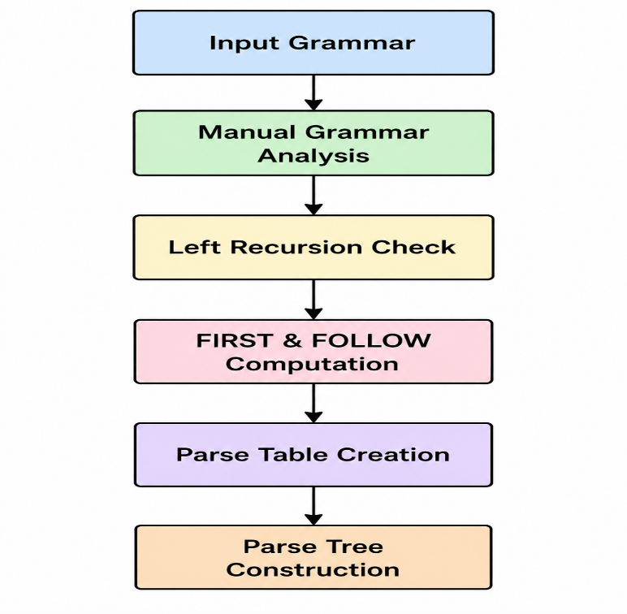

2.2 Existing Parser Generator Tools (YACC / ANTLR / JFLAP)
2.2.1 Introduction
Parser generator tools such as YACC, ANTLR, and JFLAP have been developed to automate grammar processing and parser generation. These tools reduce manual effort by automatically constructing parsers from grammar specifications. They are widely used in compiler construction and educational environments for testing grammar rules and parsing techniques.
YACC is mainly used with the C programming language to generate LALR parsers, while ANTLR supports multiple programming languages and generates recursive descent parsers. JFLAP is an educational tool that helps students visualize automata, grammars, and parsing concepts. Although these tools are powerful, they primarily focus on parser generation rather than providing a complete educational environment for grammar analysis.
2.2.2 Merits, Demerits and Challenges
Merits
- Automatic parser generation.
- Faster than manual analysis.
- Supports complex grammars.
- Reduces programming effort.
Demerits
- Difficult for beginners.
- Requires syntax learning.
- Limited educational explanation.
- Some tools have complex interfaces.
Challenges
- Learning tool-specific grammar syntax.
- Debugging parser conflicts.

2.2.3 Implementation of Existing Parser Generator Tools
Parser generator tools require users to define grammar rules in a specific syntax supported by the tool. The grammar is processed automatically to generate parser code. The generated parser validates input strings and reports syntax errors. Some tools also generate parse trees or abstract syntax trees. However, they generally do not provide complete grammar analysis features such as automatic left recursion removal, left factoring, or detailed educational explanations.
2.3 LL(1) Parsing Techniques
2.3.1 Introduction
LL(1) parsing is one of the most widely used top-down parsing techniques in Compiler Design. It reads the input from Left to Right, produces a Leftmost Derivation, and uses one look-ahead symbol to make parsing decisions. LL(1) parsers require grammars to be free from left recursion and common prefixes, making grammar transformation an essential preprocessing step.
The LL(1) parsing process involves computing FIRST and FOLLOW sets, constructing an LL(1) parsing table, and validating input strings using stack-based predictive parsing. Due to its simplicity and efficiency, LL(1) parsing is widely taught in compiler design courses and forms the foundation for understanding predictive parsers.
2.3.2 Merits, Demerits and Challenges
Merits
- Simple and efficient.
- Easy to implement.
- Fast predictive parsing.
- Produces deterministic parsing.
Demerits
- Supports only LL(1) grammars.
- Cannot handle ambiguous grammars.
- Requires grammar transformations.
- Limited flexibility for complex languages.
Challenges
- Removing left recursion.
- Performing left factoring.
- Computing accurate FIRST and FOLLOW sets.
- Constructing conflict-free parsing tables.
2.3.3 Implementation of LL(1) Parsing Techniques
The LL(1) parser first validates the grammar and transforms it by removing left recursion and applying left factoring if necessary. FIRST and FOLLOW sets are computed for all non-terminals, and an LL(1) parsing table is generated. The parser then processes the input string using a stack and the parsing table. During parsing, leftmost derivation steps are generated, and after successful parsing, the parse tree is constructed. This technique provides efficient predictive parsing while maintaining simplicity and deterministic behavior, making it suitable for educational compiler design applications.

CHAPTER 3
PROPOSED SYSTEM

CHAPTER 3
PROPOSED SYSTEM
3.1 Objective of Proposed Model
The primary objective of the proposed model is to develop an interactive Grammar Analyzer and Parse Tree Generator using Python and Tkinter that simplifies the understanding of Compiler Design concepts. The application accepts Context-Free Grammar (CFG) rules and an input string as input and performs complete grammar analysis automatically. The proposed system aims to reduce manual effort involved in grammar transformations and parsing by providing an integrated platform for grammar validation, left recursion removal, left factoring, FIRST and FOLLOW set generation, LL(1) parsing table construction, string validation, derivation generation, and parse tree visualization.
The proposed model is designed to provide an educational environment where students can easily understand grammar analysis through graphical visualization and step-by-step execution. Unlike traditional methods that require manual calculations, the system automates every stage of grammar processing and presents the results in a user-friendly graphical interface. The application also improves learning by displaying leftmost derivation, rightmost derivation, and a color-coded parse tree that clearly differentiates terminals and non-terminals.
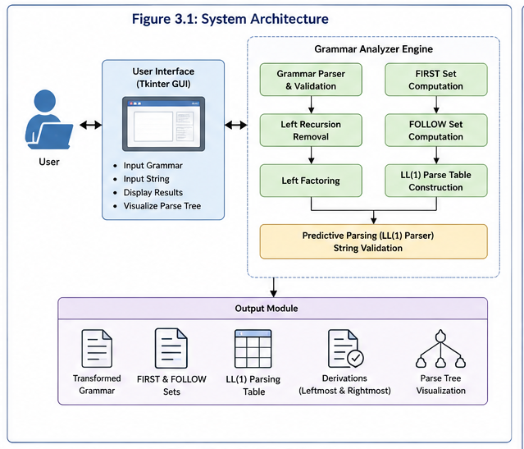

3.2 Algorithms Used for Proposed Model
The proposed system uses several compiler design algorithms to perform grammar analysis and parse tree generation. The main algorithms implemented in the application are:
1. Grammar Parsing Algorithm
Reads grammar rules entered by the user and stores them in an internal data structure.
2. Grammar Validation Algorithm
Checks grammar syntax, production rules, undefined symbols, duplicate productions, and invalid grammar formats.
3. Left Recursion Detection Algorithm
Detects both direct and indirect left recursion in Context-Free Grammars.
4. Left Recursion Removal Algorithm
Transforms left-recursive grammars into equivalent grammars suitable for LL(1) parsing.
5. Left Factoring Algorithm
Identifies common prefixes among productions and removes ambiguity by creating new non-terminals.
6. FIRST Set Generation Algorithm
Computes the FIRST set for every non-terminal according to standard compiler design rules.
7. FOLLOW Set Generation Algorithm
Generates FOLLOW sets using FIRST sets and production rules.
8. LL(1) Parsing Table Algorithm
Constructs the LL(1) parsing table using FIRST and FOLLOW sets.
9. Predictive Parsing Algorithm
Validates the input string using stack-based LL(1) parsing.
10. Derivation Generation Algorithm
Generates Leftmost and Rightmost derivations step-by-step.
11. Parse Tree Construction Algorithm
Builds the parse tree from the parsing process.
12. Parse Tree Visualization Algorithm
Displays the parse tree graphically using Tkinter Canvas with colored nodes and connecting edges.
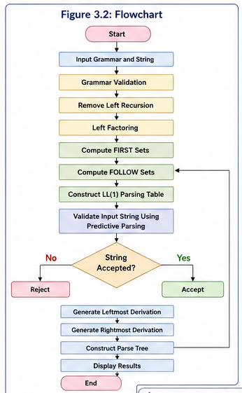

3.3 Designing
The proposed system is designed using a modular architecture consisting of multiple interconnected modules. Each module performs a specific compiler design operation, making the application easier to maintain and extend.
The system consists of the following modules:
- User Interface Module
- Grammar Parser Module
- Grammar Validation Module
- Left Recursion Removal Module
- Left Factoring Module
- FIRST & FOLLOW Module
- LL(1) Parsing Table Module
- String Validation Module
- Derivation Generator Module
- Parse Tree Generator Module
- Graphical Visualization Module
The modular design ensures that each component performs an independent task while collectively producing the final grammar analysis output.
3.3.1 UML Diagram
The proposed system can be represented using UML diagrams to illustrate its structure and functionality.
The following UML diagrams are included:
- Use Case Diagram
- Activity Diagram
- Sequence Diagram
- Class Diagram
These diagrams describe the interaction between the user and the application, the flow of execution, and the relationship between different software components.
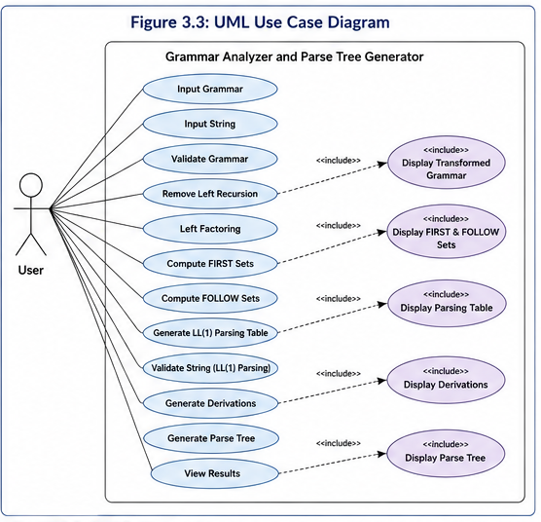
3.4 Stepwise Implementation and Code
The implementation of the proposed Grammar Analyzer follows the steps below:
Step 1: Design the graphical user interface using Python Tkinter.
Step 2: Accept grammar rules and input string from the user.
Step 3: Parse and validate the grammar.
Step 4: Detect and remove left recursion.
Step 5: Perform left factoring if required.
Step 6: Generate FIRST sets.
Step 7: Generate FOLLOW sets.
Step 8: Construct the LL(1) Parsing Table.
Step 9: Validate the input string using predictive parsing.
Step 10: Generate Leftmost Derivation.
Step 11: Generate Rightmost Derivation.
Step 12: Construct the Parse Tree.
Step 13: Display the Parse Tree graphically using Tkinter Canvas.
Step 14: Present all outputs including transformed grammar, FIRST sets, FOLLOW sets, parsing table, derivations, string validation result, and parse tree through the graphical user interface.
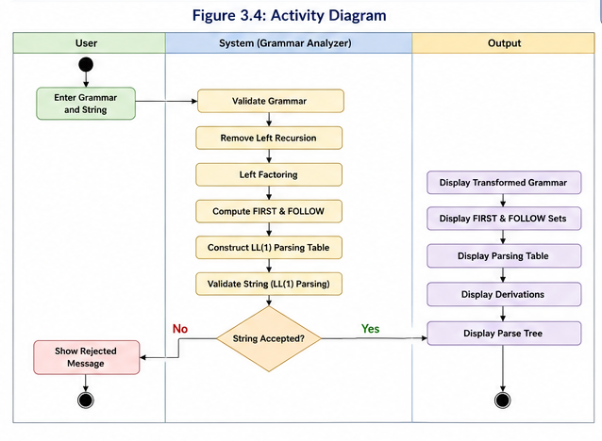

CHAPTER 4
RESULTS AND DISCUSSION

CHAPTER 4
RESULTS AND DISCUSSION
4.1 Performance Metrics
The performance of the proposed Grammar Analyzer and Parse Tree Generator using LL(1) Parsing was evaluated based on its functionality, correctness, execution speed, usability, and overall system reliability. The application was tested using various Context-Free Grammar (CFG) examples commonly used in Compiler Design. The system successfully performed grammar validation, left recursion detection and removal, left factoring, FIRST and FOLLOW set generation, LL(1) parsing table construction, string validation, derivation generation, and parse tree visualization with consistent and accurate results.
The developed application effectively analyzes the input grammar and identifies grammatical issues before processing. It automatically detects direct and indirect left recursion, performs grammar transformation, and applies left factoring whenever necessary. The generated FIRST and FOLLOW sets are accurate and are further used to construct the LL(1) parsing table. The parsing table enables efficient validation of input strings and ensures that the parsing process follows standard LL(1) parsing rules.
The graphical user interface developed using Python Tkinter provides an interactive environment where users can easily enter grammar rules and visualize the complete parsing process. The generated outputs, including transformed grammar, parsing table, derivations, and parse tree, are displayed in an organized manner, making the application easy to use for both students and educators. The parse tree visualization, with different colors representing terminals and non-terminals, further improves the understanding of grammar structures and syntax tree construction.

Table 4.1 Performance Metrics of the Proposed System
Performance Metric | Description | Result
Grammar Validation | Checks grammar correctness | Successful
Left Recursion Removal | Removes direct & indirect recursion | Successful
Left Factoring | Detects and performs left factoring | Successful
FIRST Set Generation | Computes FIRST sets | Accurate
FOLLOW Set Generation | Computes FOLLOW sets | Accurate
LL(1) Parse Table | Generates predictive parsing table | Successful
String Validation | Accepts or rejects input string | Successful
Parse Tree Generation | Constructs graphical parse tree | Successful
GUI Responsiveness | User interface performance | Fast
Overall System Performance | Complete grammar analysis | Excellent

CHAPTER 5
CONCLUSION

CHAPTER 5
CONCLUSION
The Grammar Analyzer and Parse Tree Generator using LL(1) Parsing was successfully designed and developed to simplify the understanding of Compiler Design concepts. The application provides an integrated platform for analyzing Context-Free Grammars (CFGs) by automating tasks such as grammar validation, left recursion removal, left factoring, FIRST and FOLLOW set generation, LL(1) parsing table construction, input string validation, derivation generation, and parse tree visualization. The system minimizes manual effort, reduces computational errors, and provides accurate results through a simple and interactive graphical user interface developed using Python Tkinter.
The proposed system effectively combines multiple compiler design concepts into a single educational application. The graphical representation of the parse tree and the step-by-step parsing process make complex concepts easier to understand for students and educators. Experimental results demonstrate that the application performs efficiently for standard LL(1) grammars while providing reliable and consistent outputs. Overall, the project serves as an effective learning tool that enhances practical understanding of grammar analysis and predictive parsing techniques.
Future Enhancement
Although the proposed system successfully supports LL(1) grammar analysis, several enhancements can be incorporated in future versions. The application can be extended to support advanced parsing techniques such as SLR(1), LR(1), CLR(1), and LALR(1), allowing it to analyze a wider range of grammars
Additionally, the system can be enhanced by providing options to export grammar analysis reports and parse trees in PDF or image format Integration with educational platforms and support for additional compiler design concepts, such as Abstract Syntax Tree (AST) generation, semantic analysis, and intermediate code generation, can transform the application into a comprehensive compiler learning environment.

REFERENCES

REFERENCES
[1]. Alfred V. Aho, Monica S. Lam, Ravi Sethi, Jeffrey D. Ullman, Compilers: Principles, Techniques, and Tools (2nd Edition), Addison-Wesley Professional, ISBN: 978-0321486813, 2006.
[2]. Kenneth C. Louden, Compiler Construction: Principles and Practice, Cengage Learning, ISBN: 978-8131509777, 2003.
[3]. Dick Grune, Kees van Reeuwijk, Henri E. Bal, Ceriel J.H. Jacobs, Koen Langendoen, Modern Compiler Design (2nd Edition), Springer, ISBN: 978-1461446989, 2012.
[4]. A. V. Aho and Jeffrey D. Ullman, The Theory of Parsing, Translation, and Compiling, Prentice Hall, 1972.
[5]. Python Software Foundation, Python 3 Documentation. Available: https://docs.python.org/3/
[6]. Python Software Foundation, Tkinter — Python Interface to Tcl/Tk. Available: https://docs.python.org/3/library/tkinter.html
[7]. ANTLR Project, ANTLR (Another Tool for Language Recognition). Available: https://www.antlr.org/
[8]. GNU Project, Bison Parser Generator. Available: https://www.gnu.org/software/bison/
[9]. Oracle, The Java™ Tutorials – Parsing Concepts. Available: https://docs.oracle.com/javase/tutorial/
[10]. JFLAP Team, JFLAP: An Interactive Formal Languages and Automata Package. Available: https://www.jflap.org/

GitHub Link
1. https://github.com/SrihithaBandi99/KLH-CSE-2026-27-2420030099-ParseTreeGeneratorGUI.git

